**Ideation Phase**

**Brainstorm & Idea Prioritization Template**

|  |  |
| --- | --- |
| Date | 19 September 2022 |
| Team ID | PNT2022TMID07729 |
| Project Name | Crude oil price prediction |
| Maximum Marks | 4 Marks |

**Brainstorm & Idea Prioritization Template:**

**Step-1: Team Gathering, Collaboration and Select the Problem Statement**

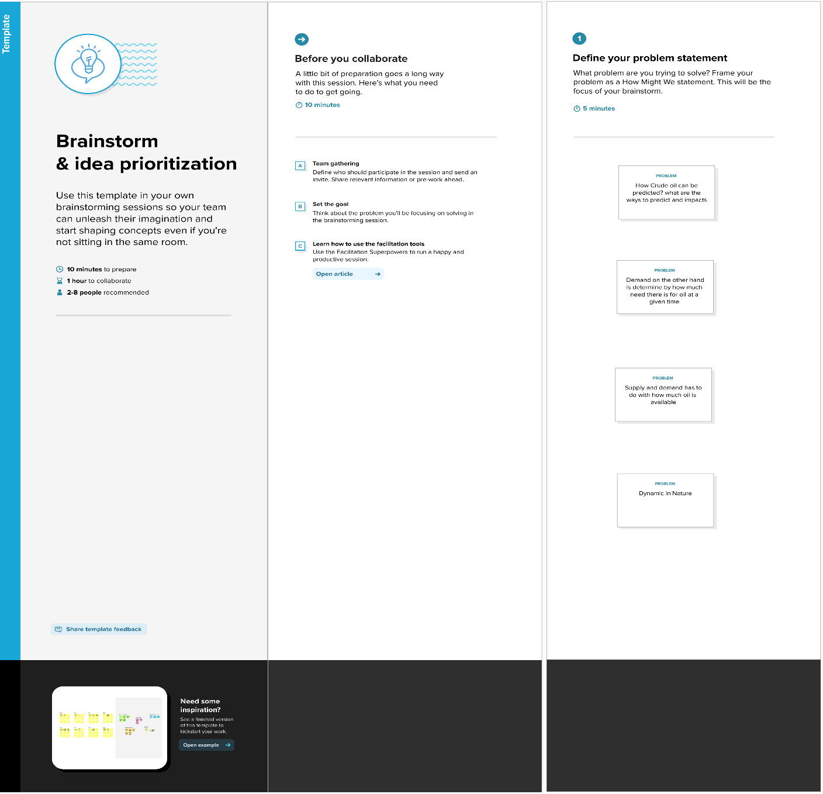

**Step-2: Brainstorm, Idea Listing and Grouping**

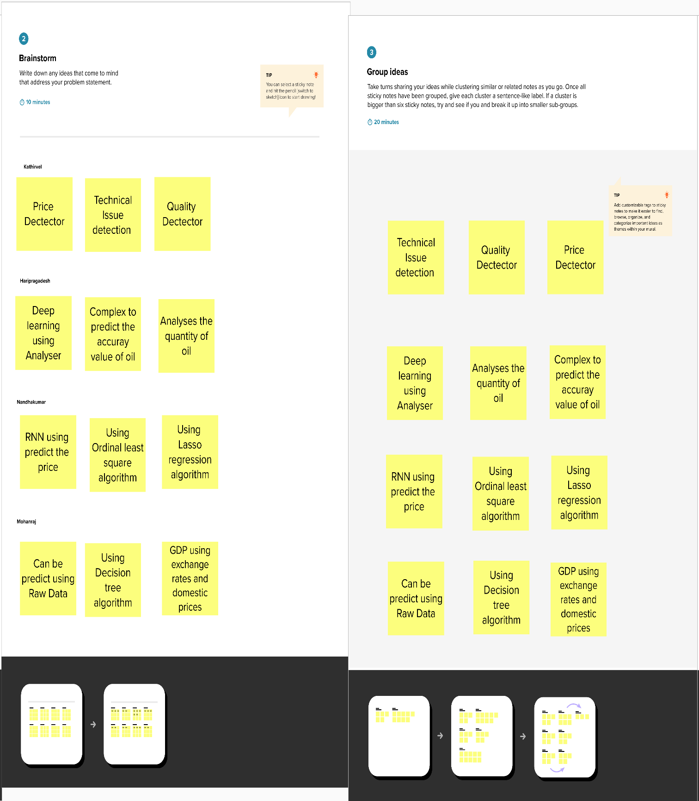

**Step-3: Idea Prioritization**

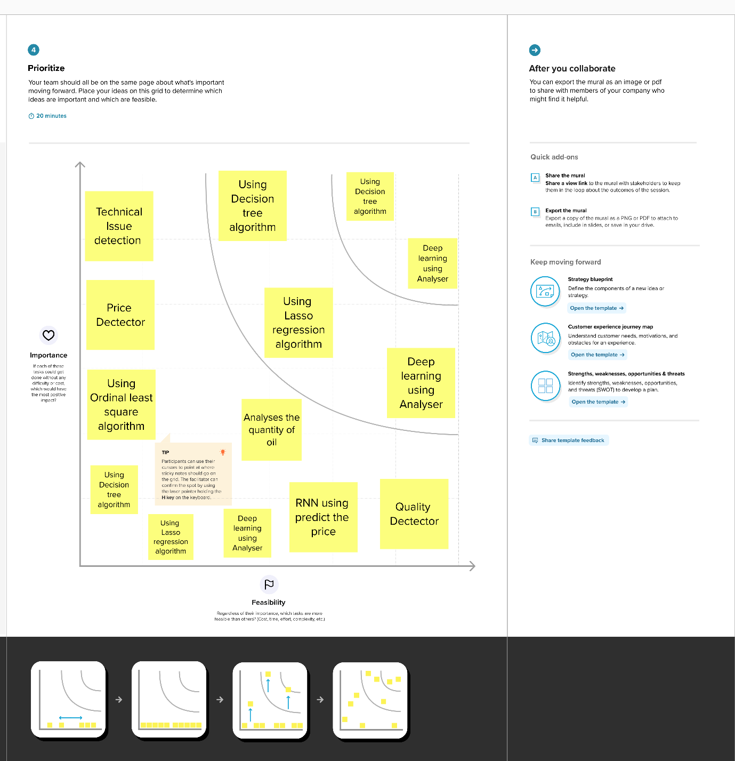

Reference:https://app.mural.co/invitation/mural/ibm7868/1663861374070?sender=u0bf93a6bfafab0f9ccad2595&key=52be5603-517d-4332-bc03-17010882e09c